Visit notes classifier: accuracy report
Nov 4, 2026 · @Amar Sankar Kar
TerritoryIQ reads each sales rep's visit note and labels what the visit was about. Checked against 34 real visits labelled by hand, it gets 79% right overall, and 90% of the visits it decides by itself. The rest it flags for a person to check.

Results
Out of every 100 visits, about 79 are labelled correctly with no one checking, 12 are flagged for a person to check, and 9 are labelled wrongly without a flag.
What the system reads from the note | Visits checked | Correct
What the visit was about (one of 10 topics, e.g. order, payment, complaint) | 34 | 79% (27 of 34)
The same, on visits it decided without flagging | 30 | 90% (27 of 30)
How urgent it is (4 levels) | 34 | 82% (28 of 34)
The customer's mood (positive, neutral, negative) | 34 | 91%
What the customer is asking for (credit, price, scheme, quality) | 34 | 91%
Tonnes and competitor brand, when the rep said them | 6 | 100% (6 of 6)
All 4 visits it flagged were ones it would have got wrong, so the flag is doing its job. The figures for mood and requests come from the same 34 visits, tested on 2 November 2026.

Accuracy by visit topic
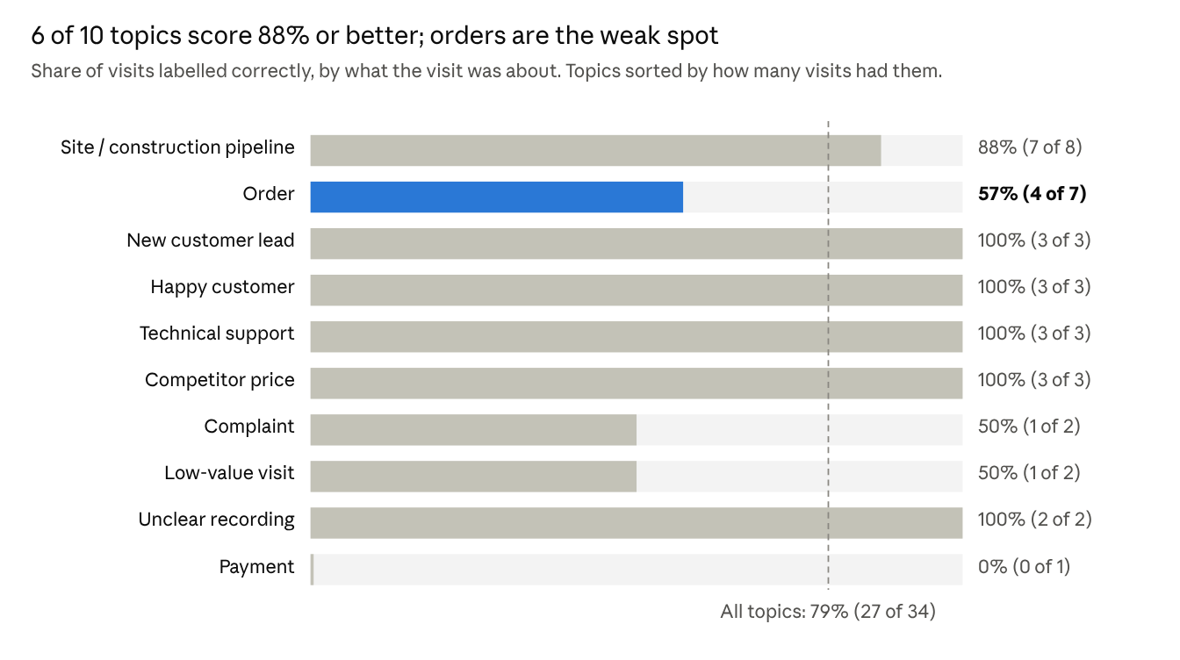
TerritoryIQ visit-intel evaluation, leave-one-out on 34 hand-labelled visits, re-run 4 November 2026
Orders matter most to sales and are the weakest topic: 3 of the 7 order visits were missed, mostly labelled as site visits. Several topics had only 1 to 3 visits to test, so their scores can swing a lot.

Why this method
Combining three checks beats every single method we tried: 79% against 56% for the best of 28 standard machine-learning models. The three checks are fixed rules, a keyword list that includes Bengali and Hindi slang, and a small model trained on our own visits. When they disagree, the visit is flagged instead of guessed.
Method, tested on the same 34 visits | Correct
TerritoryIQ (rules + keywords + model, with flagging) | 79%
Keyword rules alone | 65%
Best standard model (Ridge classifier, best of 28 tried) | 56%
Large models (random forest, XGBoost, neural network) | 27% to 53%
Standard models do badly here because 34 visits are too few for them to learn 10 topics. The rules and keywords carry the result until more visits are labelled. Each visit was tested by a model that had never seen it (leave-one-out), so these numbers are not inflated.

How far to trust these numbers
Treat them as an early reading, not a final score. They rest on 34 visits, each labelled by one person. With so few visits, the true overall accuracy could be anywhere from about 63% to 90%.
What will raise accuracy and make it more certain:
- More checked visits. About 300 visits labelled by hand, ideally by two people, would narrow the range to a few points and let the model learn properly.
- Full visit data from Frontier. We need the rep's own words in Bengali or Hindi, not only the short English summary. We are asking the Frontier team for this.
- Better notes from reps. The average note scores 4.9 out of 10 today. The voice-note guide teaches reps to start each note with a one-word headline (ORDER, PAYMENT, COMPLAINT and so on), which the system reads directly.
The weakest topics today are orders (4 of 7 right) and payment (0 of 1). Order visits were most often mistaken for site visits.

